**Project Design Phase-II**

**Data Flow Diagram & User Stories**

|  |  |
| --- | --- |
| Date | 18 June 2025 |
| Team ID | LTVIP2025TMID51528 |
| Project Name | Visualizing Housing Market Trends: An Analysis Of Sale Prices and Features Using Tableau |
| Maximum Marks | 4 Marks |

**Data Flow Diagrams:**

A Data Flow Diagram (DFD) is a traditional visual representation of the informatison flows within a system. A neat and clear DFD can depict the right amount of the system requirement graphically. It shows how data enters and leaves the system, what changes the information, and where data is stored.

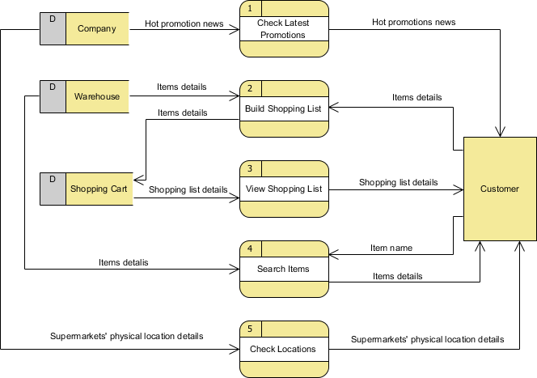

## **User Stories**

Use the below table to define user stories for this project:

| **Activity** | **User Story (Top Priority)** | **Story (Enhancement)** | **Story (Later Release)** |
| --- | --- | --- | --- |
| **Explore Metrics** | As Retail Manager, I want to view sales by placement zone so I can identify top-performing areas | As Data Analyst, I want drill‑down filters by category so I can segment performance | As Marketing Lead, I want trend lines across weeks so I can track seasonality |
| **Analyze Zones** | As Visual Merch, I want heatmaps of traffic so I can optimize layout | As Retail Manager, I want to compare front‑ vs. back‑store performance | As Executives, I want to flag low-performing zones and get alerts |
| **Compare Placements** | As Marketing Manager, I want to compare placement types (shelf vs endcap) so I can evaluate ROI | As Brand Strategist, I want time‑series comparison of placements | As Data Analyst, I want benchmarking vs. last quarter |
| **Export Insights** | As Brand Strategist, I want exportable dashboard PDFs so I can present findings | As Retail Manager, I want annotated screenshots of charts | As Executive, I want email summary alerts of underperformance |
| **Take Action** | As Strategy Lead, I want recommendations for placement changes so I can drive layout updates | As Retail Manager, I want to model sales impact for repositioning | As Data Analyst, I want predictive placement modeling |